Data Mining Assignment

Group1

July 23, 2017

# Author : Santhosh, Krishn

# Date : 17-Jul-2017

# a) Data Import (Target variable is "Attrition" column)

# b) Split the data in Dev & Hold Out sample (70:30)

# c) Perform Exploratory Data Analysis

# d) Identify columns which are of no use. drop those columns

# e) Write Hypothesis and validate the Hypothesis

# f) Build Neural Network Model (Development sample)

# g) Validate NN model on Hold Out. If need be improvize

# h) Build Random Forest Model

# i) Validate RF Model

# j) Compare NN with RF

# k) Combine NN and RF into Ensemble Model

# l) Check whether Ensemble Model Performance outperforms the individual RF & NN model

library(scales)  
library(RColorBrewer)  
library(neuralnet)  
library(googleVis)

## Creating a generic function for 'toJSON' from package 'jsonlite' in package 'googleVis'

##   
## Welcome to googleVis version 0.6.2  
##   
## Please read Google's Terms of Use  
## before you start using the package:  
## https://developers.google.com/terms/  
##   
## Note, the plot method of googleVis will by default use  
## the standard browser to display its output.  
##   
## See the googleVis package vignettes for more details,  
## or visit http://github.com/mages/googleVis.  
##   
## To suppress this message use:  
## suppressPackageStartupMessages(library(googleVis))

library(data.table)  
library(caret)

## Loading required package: lattice

## Loading required package: ggplot2

library(ROCR)

## Loading required package: gplots

##   
## Attaching package: 'gplots'

## The following object is masked from 'package:stats':  
##   
## lowess

##   
## Attaching package: 'ROCR'

## The following object is masked from 'package:neuralnet':  
##   
## prediction

library(randomForest)

## randomForest 4.6-12

## Type rfNews() to see new features/changes/bug fixes.

##   
## Attaching package: 'randomForest'

## The following object is masked from 'package:ggplot2':  
##   
## margin

library(ineq)  
  
  
getwd()

## [1] "C:/Home/Work/GreatLakes/Data Mining/Assignments/NeuralNet and RF"

setwd("C:/Home/Work/GreatLakes/Data Mining/Assignments/NeuralNet and RF")  
darkCol = brewer.pal(9, "Set1")  
  
HRSourceData = read.table("C:/Home/Work/GreatLakes/Data Mining/Assignments/NeuralNet and RF/1452762979_586__HR_Employee_Attrition_Data.csv", header = T, sep=",")  
  
  
  
#Data Preparation  
# Target data is a factor of String, converting it to Integer of 0 or 1  
Target_Attrition = as.vector(HRSourceData$Attrition)  
Target_Attrition = replace(Target_Attrition,Target_Attrition=="No",0)  
Target_Attrition = replace(Target_Attrition,Target_Attrition=="Yes",1)  
Target_Attrition = as.integer(Target_Attrition)  
HRSourceData$TargetAttrition = Target_Attrition  
  
#plot(gvisTable(HRSourceData))  
names(HRSourceData)

## [1] "Age" "Attrition"   
## [3] "BusinessTravel" "DailyRate"   
## [5] "Department" "DistanceFromHome"   
## [7] "Education" "EducationField"   
## [9] "EmployeeCount" "EmployeeNumber"   
## [11] "EnvironmentSatisfaction" "Gender"   
## [13] "HourlyRate" "JobInvolvement"   
## [15] "JobLevel" "JobRole"   
## [17] "JobSatisfaction" "MaritalStatus"   
## [19] "MonthlyIncome" "MonthlyRate"   
## [21] "NumCompaniesWorked" "Over18"   
## [23] "OverTime" "PercentSalaryHike"   
## [25] "PerformanceRating" "RelationshipSatisfaction"  
## [27] "StandardHours" "StockOptionLevel"   
## [29] "TotalWorkingYears" "TrainingTimesLastYear"   
## [31] "WorkLifeBalance" "YearsAtCompany"   
## [33] "YearsInCurrentRole" "YearsSinceLastPromotion"   
## [35] "YearsWithCurrManager" "TargetAttrition"

str(HRSourceData)

## 'data.frame': 2940 obs. of 36 variables:  
## $ Age : int 41 49 37 33 27 32 59 30 38 36 ...  
## $ Attrition : Factor w/ 2 levels "No","Yes": 2 1 2 1 1 1 1 1 1 1 ...  
## $ BusinessTravel : Factor w/ 3 levels "Non-Travel","Travel_Frequently",..: 3 2 3 2 3 2 3 3 2 3 ...  
## $ DailyRate : int 1102 279 1373 1392 591 1005 1324 1358 216 1299 ...  
## $ Department : Factor w/ 3 levels "Human Resources",..: 3 2 2 2 2 2 2 2 2 2 ...  
## $ DistanceFromHome : int 1 8 2 3 2 2 3 24 23 27 ...  
## $ Education : int 2 1 2 4 1 2 3 1 3 3 ...  
## $ EducationField : Factor w/ 6 levels "Human Resources",..: 2 2 5 2 4 2 4 2 2 4 ...  
## $ EmployeeCount : int 1 1 1 1 1 1 1 1 1 1 ...  
## $ EmployeeNumber : int 1 2 3 4 5 6 7 8 9 10 ...  
## $ EnvironmentSatisfaction : int 2 3 4 4 1 4 3 4 4 3 ...  
## $ Gender : Factor w/ 2 levels "Female","Male": 1 2 2 1 2 2 1 2 2 2 ...  
## $ HourlyRate : int 94 61 92 56 40 79 81 67 44 94 ...  
## $ JobInvolvement : int 3 2 2 3 3 3 4 3 2 3 ...  
## $ JobLevel : int 2 2 1 1 1 1 1 1 3 2 ...  
## $ JobRole : Factor w/ 9 levels "Healthcare Representative",..: 8 7 3 7 3 3 3 3 5 1 ...  
## $ JobSatisfaction : int 4 2 3 3 2 4 1 3 3 3 ...  
## $ MaritalStatus : Factor w/ 3 levels "Divorced","Married",..: 3 2 3 2 2 3 2 1 3 2 ...  
## $ MonthlyIncome : int 5993 5130 2090 2909 3468 3068 2670 2693 9526 5237 ...  
## $ MonthlyRate : int 19479 24907 2396 23159 16632 11864 9964 13335 8787 16577 ...  
## $ NumCompaniesWorked : int 8 1 6 1 9 0 4 1 0 6 ...  
## $ Over18 : Factor w/ 1 level "Y": 1 1 1 1 1 1 1 1 1 1 ...  
## $ OverTime : Factor w/ 2 levels "No","Yes": 2 1 2 2 1 1 2 1 1 1 ...  
## $ PercentSalaryHike : int 11 23 15 11 12 13 20 22 21 13 ...  
## $ PerformanceRating : int 3 4 3 3 3 3 4 4 4 3 ...  
## $ RelationshipSatisfaction: int 1 4 2 3 4 3 1 2 2 2 ...  
## $ StandardHours : int 80 80 80 80 80 80 80 80 80 80 ...  
## $ StockOptionLevel : int 0 1 0 0 1 0 3 1 0 2 ...  
## $ TotalWorkingYears : int 8 10 7 8 6 8 12 1 10 17 ...  
## $ TrainingTimesLastYear : int 0 3 3 3 3 2 3 2 2 3 ...  
## $ WorkLifeBalance : int 1 3 3 3 3 2 2 3 3 2 ...  
## $ YearsAtCompany : int 6 10 0 8 2 7 1 1 9 7 ...  
## $ YearsInCurrentRole : int 4 7 0 7 2 7 0 0 7 7 ...  
## $ YearsSinceLastPromotion : int 0 1 0 3 2 3 0 0 1 7 ...  
## $ YearsWithCurrManager : int 5 7 0 0 2 6 0 0 8 7 ...  
## $ TargetAttrition : int 1 0 1 0 0 0 0 0 0 0 ...

#List of Numerical Variable  
# Age : COnt  
# DailyRate : Ratio  
# Distance from Home : Ratio  
# Education : Ordinal  
# Employee Count : Discrete  
# Employee Number : Nominal  
# Employee Satisfaction : Ordinal  
# Hourly Rate : Cont, Ratio  
# Job Involvement : Discrete  
# Job Level : Ordinal  
# Job Satisfaction : Ordinal  
# Monthly Income : Ratio, Cont  
# Monthly Rate : Ration, cont  
# Num Company Worked : Discrete  
# Percent Salaray Hike : Interval, Cont  
# Performance Rating : Ordinal  
# Relationship Satisfaction : Ordinal  
# Standard Hours : Cont  
# Stock Option Level : Ordinal  
# Total Working Years : Discrete  
# Training Times Last Year : Discrete  
# Work Life Balance : Ordinal  
# Years at Company : Cont, Interval  
# Years in Current Role : Cont, Interval  
# Years Since Last Promotion : Cont, Interval  
# Years with Current Manager : Cont, Interval  
  
#List of Categorical Variable  
#BusinessTravel  
#Department  
#EducationField  
#Gender  
#JobRole  
#MaritalStatus  
#Over18  
#OverTime  
  
#Business Travel  
plot(HRSourceData$BusinessTravel, col=darkCol, main = "Travel Details")

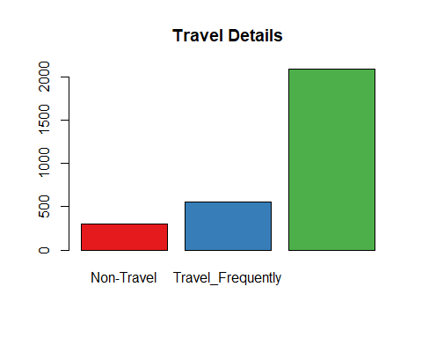

BusinessTravel = data.frame(summary(HRSourceData$BusinessTravel))  
round((BusinessTravel/sum(BusinessTravel))*100,2)

## summary.HRSourceData.BusinessTravel.  
## Non-Travel 10.20  
## Travel_Frequently 18.84  
## Travel_Rarely 70.95

#Department  
plot(HRSourceData$Department, col=darkCol, main="Department")

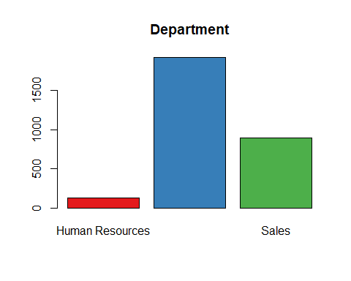

vDepartment = data.frame(summary(HRSourceData$Department))  
round((vDepartment/sum(vDepartment))*100,2)

## summary.HRSourceData.Department.  
## Human Resources 4.29  
## Research & Development 65.37  
## Sales 30.34

#EducationField  
plot(HRSourceData$EducationField, col=darkCol, main="Eduction Field")

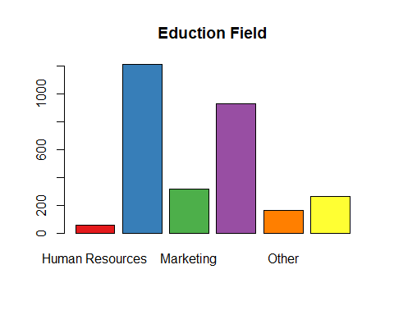

vEducationField = data.frame(summary(HRSourceData$EducationField))  
round((vEducationField/sum(vEducationField))*100,2)

## summary.HRSourceData.EducationField.  
## Human Resources 1.84  
## Life Sciences 41.22  
## Marketing 10.82  
## Medical 31.56  
## Other 5.58  
## Technical Degree 8.98

#Gender  
plot(HRSourceData$Gender, col=darkCol,main="Gender")

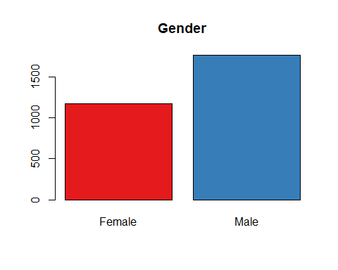

vGender = data.frame(summary(HRSourceData$Gender))  
round((vGender/sum(vGender))*100,2)

## summary.HRSourceData.Gender.  
## Female 40  
## Male 60

#JobRole  
plot(HRSourceData$JobRole, col=darkCol, main="Job Role")

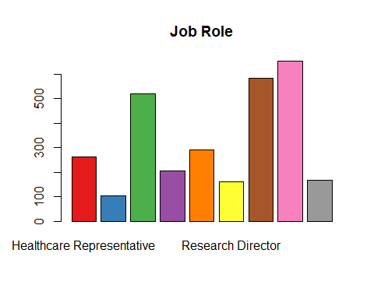

vJobRole = data.frame(summary(HRSourceData$JobRole))  
round((vJobRole/sum(vJobRole))*100,2)

## summary.HRSourceData.JobRole.  
## Healthcare Representative 8.91  
## Human Resources 3.54  
## Laboratory Technician 17.62  
## Manager 6.94  
## Manufacturing Director 9.86  
## Research Director 5.44  
## Research Scientist 19.86  
## Sales Executive 22.18  
## Sales Representative 5.65

#MaritalStatus  
plot(HRSourceData$MaritalStatus, col=darkCol, main="Marital Status")

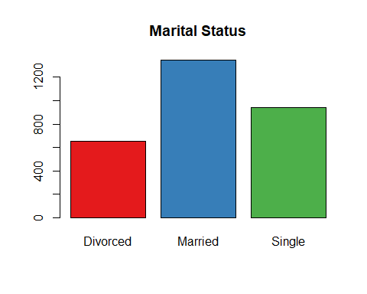

vMaritalStatus = data.frame(summary(HRSourceData$MaritalStatus))  
round((vMaritalStatus/sum(vMaritalStatus))*100,2)

## summary.HRSourceData.MaritalStatus.  
## Divorced 22.24  
## Married 45.78  
## Single 31.97

#OverTime  
plot(HRSourceData$OverTime, col=darkCol, main="Over time")

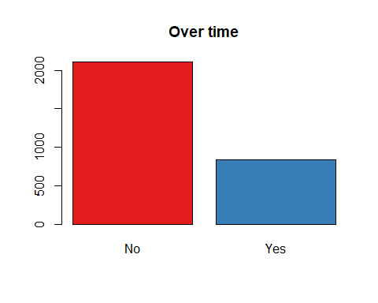

vOverTime = data.frame(summary(HRSourceData$OverTime))  
round((vOverTime/sum(vOverTime))*100,2)

## summary.HRSourceData.OverTime.  
## No 71.7  
## Yes 28.3

#Finding Ouliers in Cont data  
x = subset(HRSourceData,   
 select = c("Age",  
 "DailyRate",  
 "DistanceFromHome",  
 "Education",  
 "EmployeeCount",  
 "EmployeeNumber",  
 "EnvironmentSatisfaction",  
 "HourlyRate",  
 "JobInvolvement",  
 "JobLevel",  
 "JobSatisfaction",  
 "MonthlyIncome",  
 "MonthlyRate",  
 "NumCompaniesWorked",  
 "PercentSalaryHike",  
 "PerformanceRating",  
 "RelationshipSatisfaction",  
 "StandardHours",  
 "StockOptionLevel",  
 "TotalWorkingYears",  
 "TrainingTimesLastYear",  
 "WorkLifeBalance",  
 "YearsAtCompany",  
 "YearsInCurrentRole",  
 "YearsSinceLastPromotion",  
 "YearsWithCurrManager"))  
class(x)

## [1] "data.frame"

y = scale(x[,])  
boxplot(y, col=darkCol, main="Numerical Variables")

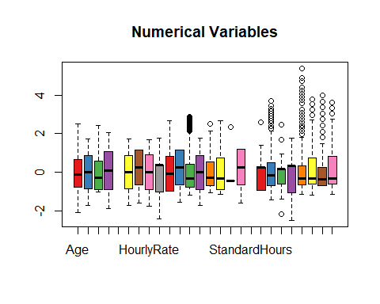

#Before splitting the data as development and holdout, let us convert the categorical variables to continous variables.  
# Get rid of variables that are of no use  
# StandardHours and Over18 are having same values for all observations, so we can remove those variables.  
CleanedHRData = HRSourceData[,!(names(HRSourceData) %in% c("EmployeeCount", "StandardHours","Over18","EmployeeNumber"))]  
  
# Converting Categorical Variables to COnt  
#BusinessTravel  
mBusinessTravel = model.matrix(~ BusinessTravel - 1, data = CleanedHRData)  
head(mBusinessTravel)

## BusinessTravelNon-Travel BusinessTravelTravel_Frequently  
## 1 0 0  
## 2 0 1  
## 3 0 0  
## 4 0 1  
## 5 0 0  
## 6 0 1  
## BusinessTravelTravel_Rarely  
## 1 1  
## 2 0  
## 3 1  
## 4 0  
## 5 1  
## 6 0

CleanedHRData = data.frame(CleanedHRData, mBusinessTravel)  
CleanedHRData = CleanedHRData[,!(names(CleanedHRData) %in% c("BusinessTravel"))]  
  
#Department  
mDepartment = model.matrix(~ Department - 1, data = CleanedHRData)  
head(mDepartment)

## DepartmentHuman Resources DepartmentResearch & Development  
## 1 0 0  
## 2 0 1  
## 3 0 1  
## 4 0 1  
## 5 0 1  
## 6 0 1  
## DepartmentSales  
## 1 1  
## 2 0  
## 3 0  
## 4 0  
## 5 0  
## 6 0

CleanedHRData = data.frame(CleanedHRData, mDepartment)  
CleanedHRData = CleanedHRData[,!(names(CleanedHRData) %in% c("Department"))]  
  
#EducationField  
mEducationField = model.matrix(~ EducationField - 1, data = CleanedHRData)  
head(mEducationField)

## EducationFieldHuman Resources EducationFieldLife Sciences  
## 1 0 1  
## 2 0 1  
## 3 0 0  
## 4 0 1  
## 5 0 0  
## 6 0 1  
## EducationFieldMarketing EducationFieldMedical EducationFieldOther  
## 1 0 0 0  
## 2 0 0 0  
## 3 0 0 1  
## 4 0 0 0  
## 5 0 1 0  
## 6 0 0 0  
## EducationFieldTechnical Degree  
## 1 0  
## 2 0  
## 3 0  
## 4 0  
## 5 0  
## 6 0

CleanedHRData = data.frame(CleanedHRData, mEducationField)  
CleanedHRData = CleanedHRData[,!(names(CleanedHRData) %in% c("EducationField"))]  
  
#Gender  
mGender = model.matrix(~ Gender - 1, data = CleanedHRData)  
head(mGender)

## GenderFemale GenderMale  
## 1 1 0  
## 2 0 1  
## 3 0 1  
## 4 1 0  
## 5 0 1  
## 6 0 1

CleanedHRData = data.frame(CleanedHRData, mGender)  
CleanedHRData = CleanedHRData[,!(names(CleanedHRData) %in% c("Gender"))]  
  
#JobRole  
mJobRole = model.matrix(~ JobRole - 1, data = CleanedHRData)  
head(mJobRole)

## JobRoleHealthcare Representative JobRoleHuman Resources  
## 1 0 0  
## 2 0 0  
## 3 0 0  
## 4 0 0  
## 5 0 0  
## 6 0 0  
## JobRoleLaboratory Technician JobRoleManager  
## 1 0 0  
## 2 0 0  
## 3 1 0  
## 4 0 0  
## 5 1 0  
## 6 1 0  
## JobRoleManufacturing Director JobRoleResearch Director  
## 1 0 0  
## 2 0 0  
## 3 0 0  
## 4 0 0  
## 5 0 0  
## 6 0 0  
## JobRoleResearch Scientist JobRoleSales Executive  
## 1 0 1  
## 2 1 0  
## 3 0 0  
## 4 1 0  
## 5 0 0  
## 6 0 0  
## JobRoleSales Representative  
## 1 0  
## 2 0  
## 3 0  
## 4 0  
## 5 0  
## 6 0

CleanedHRData = data.frame(CleanedHRData, mJobRole)  
CleanedHRData = CleanedHRData[,!(names(CleanedHRData) %in% c("JobRole"))]  
  
#MaritalStatus  
mMaritalStatus = model.matrix(~ MaritalStatus - 1, data = CleanedHRData)  
head(mMaritalStatus)

## MaritalStatusDivorced MaritalStatusMarried MaritalStatusSingle  
## 1 0 0 1  
## 2 0 1 0  
## 3 0 0 1  
## 4 0 1 0  
## 5 0 1 0  
## 6 0 0 1

CleanedHRData = data.frame(CleanedHRData, mMaritalStatus)  
CleanedHRData = CleanedHRData[,!(names(CleanedHRData) %in% c("MaritalStatus"))]  
  
#OverTime  
mOverTime = model.matrix(~ OverTime - 1, data = CleanedHRData)  
head(mOverTime)

## OverTimeNo OverTimeYes  
## 1 0 1  
## 2 1 0  
## 3 0 1  
## 4 0 1  
## 5 1 0  
## 6 1 0

CleanedHRData = data.frame(CleanedHRData, mOverTime)  
CleanedHRData = CleanedHRData[,!(names(CleanedHRData) %in% c("OverTime"))]  
  
CleanedHRData = CleanedHRData[,!(names(CleanedHRData) %in% c("Attrition"))]  
CleanedHRData = cbind(CleanedHRData[,(names(CleanedHRData) %in% c("TargetAttrition"))],  
 CleanedHRData[,!(names(CleanedHRData) %in% c("TargetAttrition"))])  
names(CleanedHRData)[1] = "TargetAttrition"  
  
  
  
  
str(CleanedHRData)

## 'data.frame': 2940 obs. of 52 variables:  
## $ TargetAttrition : int 1 0 1 0 0 0 0 0 0 0 ...  
## $ Age : int 41 49 37 33 27 32 59 30 38 36 ...  
## $ DailyRate : int 1102 279 1373 1392 591 1005 1324 1358 216 1299 ...  
## $ DistanceFromHome : int 1 8 2 3 2 2 3 24 23 27 ...  
## $ Education : int 2 1 2 4 1 2 3 1 3 3 ...  
## $ EnvironmentSatisfaction : int 2 3 4 4 1 4 3 4 4 3 ...  
## $ HourlyRate : int 94 61 92 56 40 79 81 67 44 94 ...  
## $ JobInvolvement : int 3 2 2 3 3 3 4 3 2 3 ...  
## $ JobLevel : int 2 2 1 1 1 1 1 1 3 2 ...  
## $ JobSatisfaction : int 4 2 3 3 2 4 1 3 3 3 ...  
## $ MonthlyIncome : int 5993 5130 2090 2909 3468 3068 2670 2693 9526 5237 ...  
## $ MonthlyRate : int 19479 24907 2396 23159 16632 11864 9964 13335 8787 16577 ...  
## $ NumCompaniesWorked : int 8 1 6 1 9 0 4 1 0 6 ...  
## $ PercentSalaryHike : int 11 23 15 11 12 13 20 22 21 13 ...  
## $ PerformanceRating : int 3 4 3 3 3 3 4 4 4 3 ...  
## $ RelationshipSatisfaction : int 1 4 2 3 4 3 1 2 2 2 ...  
## $ StockOptionLevel : int 0 1 0 0 1 0 3 1 0 2 ...  
## $ TotalWorkingYears : int 8 10 7 8 6 8 12 1 10 17 ...  
## $ TrainingTimesLastYear : int 0 3 3 3 3 2 3 2 2 3 ...  
## $ WorkLifeBalance : int 1 3 3 3 3 2 2 3 3 2 ...  
## $ YearsAtCompany : int 6 10 0 8 2 7 1 1 9 7 ...  
## $ YearsInCurrentRole : int 4 7 0 7 2 7 0 0 7 7 ...  
## $ YearsSinceLastPromotion : int 0 1 0 3 2 3 0 0 1 7 ...  
## $ YearsWithCurrManager : int 5 7 0 0 2 6 0 0 8 7 ...  
## $ BusinessTravelNon.Travel : num 0 0 0 0 0 0 0 0 0 0 ...  
## $ BusinessTravelTravel_Frequently : num 0 1 0 1 0 1 0 0 1 0 ...  
## $ BusinessTravelTravel_Rarely : num 1 0 1 0 1 0 1 1 0 1 ...  
## $ DepartmentHuman.Resources : num 0 0 0 0 0 0 0 0 0 0 ...  
## $ DepartmentResearch...Development: num 0 1 1 1 1 1 1 1 1 1 ...  
## $ DepartmentSales : num 1 0 0 0 0 0 0 0 0 0 ...  
## $ EducationFieldHuman.Resources : num 0 0 0 0 0 0 0 0 0 0 ...  
## $ EducationFieldLife.Sciences : num 1 1 0 1 0 1 0 1 1 0 ...  
## $ EducationFieldMarketing : num 0 0 0 0 0 0 0 0 0 0 ...  
## $ EducationFieldMedical : num 0 0 0 0 1 0 1 0 0 1 ...  
## $ EducationFieldOther : num 0 0 1 0 0 0 0 0 0 0 ...  
## $ EducationFieldTechnical.Degree : num 0 0 0 0 0 0 0 0 0 0 ...  
## $ GenderFemale : num 1 0 0 1 0 0 1 0 0 0 ...  
## $ GenderMale : num 0 1 1 0 1 1 0 1 1 1 ...  
## $ JobRoleHealthcare.Representative: num 0 0 0 0 0 0 0 0 0 1 ...  
## $ JobRoleHuman.Resources : num 0 0 0 0 0 0 0 0 0 0 ...  
## $ JobRoleLaboratory.Technician : num 0 0 1 0 1 1 1 1 0 0 ...  
## $ JobRoleManager : num 0 0 0 0 0 0 0 0 0 0 ...  
## $ JobRoleManufacturing.Director : num 0 0 0 0 0 0 0 0 1 0 ...  
## $ JobRoleResearch.Director : num 0 0 0 0 0 0 0 0 0 0 ...  
## $ JobRoleResearch.Scientist : num 0 1 0 1 0 0 0 0 0 0 ...  
## $ JobRoleSales.Executive : num 1 0 0 0 0 0 0 0 0 0 ...  
## $ JobRoleSales.Representative : num 0 0 0 0 0 0 0 0 0 0 ...  
## $ MaritalStatusDivorced : num 0 0 0 0 0 0 0 1 0 0 ...  
## $ MaritalStatusMarried : num 0 1 0 1 1 0 1 0 0 1 ...  
## $ MaritalStatusSingle : num 1 0 1 0 0 1 0 0 1 0 ...  
## $ OverTimeNo : num 0 1 0 0 1 1 0 1 1 1 ...  
## $ OverTimeYes : num 1 0 1 1 0 0 1 0 0 0 ...

#Test for Significance using Anova  
fit1 = aov(TargetAttrition ~ ., data = CleanedHRData)  
summary(fit1)

## Df Sum Sq Mean Sq F value Pr(>F)   
## Age 1 10.08 10.077 98.845 < 2e-16 ***  
## DailyRate 1 1.20 1.201 11.779 0.000607 ***  
## DistanceFromHome 1 2.38 2.381 23.353 1.42e-06 ***  
## Education 1 0.00 0.000 0.004 0.951795   
## EnvironmentSatisfaction 1 3.95 3.946 38.703 5.65e-10 ***  
## HourlyRate 1 0.03 0.033 0.322 0.570205   
## JobInvolvement 1 6.14 6.138 60.205 1.18e-14 ***  
## JobLevel 1 4.62 4.619 45.311 2.02e-11 ***  
## JobSatisfaction 1 4.54 4.542 44.552 2.96e-11 ***  
## MonthlyIncome 1 0.02 0.024 0.239 0.624739   
## MonthlyRate 1 0.17 0.172 1.685 0.194320   
## NumCompaniesWorked 1 3.53 3.533 34.653 4.39e-09 ***  
## PercentSalaryHike 1 0.20 0.199 1.948 0.162920   
## PerformanceRating 1 0.10 0.104 1.024 0.311695   
## RelationshipSatisfaction 1 0.62 0.615 6.034 0.014094 *   
## StockOptionLevel 1 6.94 6.942 68.097 2.34e-16 ***  
## TotalWorkingYears 1 0.66 0.659 6.465 0.011051 *   
## TrainingTimesLastYear 1 1.34 1.339 13.133 0.000295 ***  
## WorkLifeBalance 1 1.39 1.393 13.665 0.000223 ***  
## YearsAtCompany 1 0.03 0.030 0.298 0.585317   
## YearsInCurrentRole 1 2.51 2.512 24.641 7.30e-07 ***  
## YearsSinceLastPromotion 1 2.36 2.360 23.152 1.57e-06 ***  
## YearsWithCurrManager 1 1.92 1.917 18.808 1.49e-05 ***  
## BusinessTravelNon.Travel 1 2.47 2.470 24.229 9.03e-07 ***  
## BusinessTravelTravel_Frequently 1 4.06 4.061 39.835 3.19e-10 ***  
## DepartmentHuman.Resources 1 0.04 0.043 0.421 0.516369   
## DepartmentResearch...Development 1 3.38 3.377 33.124 9.55e-09 ***  
## EducationFieldHuman.Resources 1 0.36 0.364 3.573 0.058835 .   
## EducationFieldLife.Sciences 1 0.16 0.159 1.559 0.211916   
## EducationFieldMarketing 1 0.11 0.112 1.098 0.294718   
## EducationFieldMedical 1 1.10 1.101 10.802 0.001026 **   
## EducationFieldOther 1 0.98 0.979 9.603 0.001961 **   
## GenderFemale 1 0.49 0.491 4.817 0.028255 *   
## JobRoleHealthcare.Representative 1 0.53 0.532 5.216 0.022452 *   
## JobRoleHuman.Resources 1 0.02 0.025 0.245 0.620641   
## JobRoleLaboratory.Technician 1 2.01 2.006 19.674 9.52e-06 ***  
## JobRoleManager 1 0.00 0.002 0.018 0.891877   
## JobRoleManufacturing.Director 1 0.11 0.115 1.126 0.288661   
## JobRoleResearch.Director 1 0.00 0.003 0.032 0.858377   
## JobRoleResearch.Scientist 1 0.35 0.353 3.462 0.062910 .   
## JobRoleSales.Executive 1 2.57 2.568 25.193 5.50e-07 ***  
## MaritalStatusDivorced 1 0.10 0.099 0.973 0.324081   
## MaritalStatusMarried 1 3.25 3.251 31.893 1.79e-08 ***  
## OverTimeNo 1 25.59 25.589 250.999 < 2e-16 ***  
## Residuals 2895 295.14 0.102   
## ---  
## Signif. codes: 0 '***' 0.001 '**' 0.01 '*' 0.05 '.' 0.1 ' ' 1

#Following Variables came out as insignificant, it can be dropped from the data set.  
# Df Sum Sq Mean Sq F value Pr(>F)  
#Education 1 0.00 0.000 0.004 0.952001   
#HourlyRate 1 0.03 0.033 0.320 0.571858   
#MonthlyIncome 1 0.02 0.024 0.237 0.626222   
#MonthlyRate 1 0.17 0.172 1.671 0.196237   
#PercentSalaryHike 1 0.20 0.199 1.931 0.164728   
#PerformanceRating 1 0.10 0.104 1.015 0.313771   
#YearsAtCompany 1 0.03 0.030 0.295 0.586925   
#JobRoleHuman.Resources 1 0.03 0.026 0.252 0.615773   
#JobRoleManager 1 0.01 0.006 0.060 0.806153   
#MaritalStatusDivorced 1 0.11 0.110 1.065 0.302052   
CleanedHRData = CleanedHRData[,!(names(CleanedHRData) %in% c("Education","HourlyRate",  
 "MonthlyIncome","MonthlyRate",  
 "PercentSalaryHike", "PerformanceRating",  
 "YearsAtCompany","JobRoleHuman.Resources",  
 "JobRoleManager", "MaritalStatusDivorced"))]  
fit2 = aov(TargetAttrition ~ ., data = CleanedHRData)  
summary(fit2)

## Df Sum Sq Mean Sq F value Pr(>F)   
## Age 1 10.08 10.077 98.733 < 2e-16 ***  
## DailyRate 1 1.20 1.201 11.765 0.000612 ***  
## DistanceFromHome 1 2.38 2.381 23.326 1.44e-06 ***  
## EnvironmentSatisfaction 1 3.94 3.940 38.604 5.94e-10 ***  
## JobInvolvement 1 6.17 6.170 60.449 1.04e-14 ***  
## JobLevel 1 4.59 4.594 45.008 2.35e-11 ***  
## JobSatisfaction 1 4.46 4.464 43.736 4.46e-11 ***  
## NumCompaniesWorked 1 3.53 3.535 34.632 4.44e-09 ***  
## RelationshipSatisfaction 1 0.58 0.580 5.681 0.017211 *   
## StockOptionLevel 1 7.11 7.107 69.635 < 2e-16 ***  
## TotalWorkingYears 1 0.61 0.610 5.973 0.014587 *   
## TrainingTimesLastYear 1 1.34 1.340 13.125 0.000296 ***  
## WorkLifeBalance 1 1.40 1.397 13.684 0.000220 ***  
## YearsInCurrentRole 1 1.73 1.729 16.943 3.96e-05 ***  
## YearsSinceLastPromotion 1 3.10 3.104 30.411 3.80e-08 ***  
## YearsWithCurrManager 1 1.22 1.217 11.925 0.000562 ***  
## BusinessTravelNon.Travel 1 2.47 2.469 24.190 9.21e-07 ***  
## BusinessTravelTravel_Frequently 1 4.17 4.169 40.848 1.91e-10 ***  
## DepartmentHuman.Resources 1 0.08 0.081 0.792 0.373623   
## DepartmentResearch...Development 1 3.37 3.370 33.021 1.01e-08 ***  
## EducationFieldHuman.Resources 1 0.35 0.351 3.436 0.063893 .   
## EducationFieldLife.Sciences 1 0.17 0.171 1.671 0.196284   
## EducationFieldMarketing 1 0.11 0.108 1.061 0.303092   
## EducationFieldMedical 1 1.02 1.022 10.018 0.001566 **   
## EducationFieldOther 1 1.03 1.029 10.080 0.001514 **   
## GenderFemale 1 0.49 0.486 4.759 0.029230 *   
## JobRoleHealthcare.Representative 1 0.57 0.573 5.617 0.017856 *   
## JobRoleLaboratory.Technician 1 2.11 2.107 20.640 5.77e-06 ***  
## JobRoleManufacturing.Director 1 0.16 0.164 1.609 0.204785   
## JobRoleResearch.Director 1 0.01 0.010 0.095 0.758519   
## JobRoleResearch.Scientist 1 0.23 0.233 2.282 0.130957   
## JobRoleSales.Executive 1 1.16 1.159 11.353 0.000763 ***  
## JobRoleSales.Representative 1 1.33 1.326 12.989 0.000319 ***  
## MaritalStatusMarried 1 1.25 1.246 12.203 0.000484 ***  
## MaritalStatusSingle 1 1.97 1.971 19.314 1.15e-05 ***  
## OverTimeNo 1 25.80 25.799 252.776 < 2e-16 ***  
## Residuals 2903 296.29 0.102   
## ---  
## Signif. codes: 0 '***' 0.001 '**' 0.01 '*' 0.05 '.' 0.1 ' ' 1

# Attrition Propotion

PopulationPropotion = sum(CleanedHRData$TargetAttrition)/nrow(CleanedHRData) percent(PopulationPropotion)

# Common for both NN and RF

# Sampling

sampleIndex = sample(nrow(CleanedHRData), nrow(CleanedHRData)*.7) #Splitting of Data #Training Data HrDev = CleanedHRData[sampleIndex,] #Testing Data HrHoldOut = CleanedHRData[-sampleIndex,]

# Exloratory Data analysis (c)

# Data Count on Development and HOld Out

# Development Sample

dim(HrDev)

# Holdout Sample

dim(HrHoldOut)

# Propotions comparison

# Propotion in Dev

DevPropotion = sum(HrDev$TargetAttrition)/(nrow(HrDev)) DevPropotion

# Propotion in Holdout

HOPropotion = sum(HrHoldOut$TargetAttrition)/(nrow(HrDev)) HOPropotion

PopulationPropotion

rbind(PopulationPropotion,DevPropotion, HOPropotion) # Comparison of the Distribution of Data.

# Building Neural Network Model

# For Building the Neural net, we have to be keen in selecting following parameters

# number hidden layers

# Number of neuron (tumbrule is sqrt)

# epoh

# Activation Function

# avoiding overfitting.

# function for dealing with error

# threshold - important factor that decides over fitting.

# stopmax

# learning rate

names(CleanedHRData) nn1 = neuralnet(TargetAttrition ~ Age + DailyRate + DistanceFromHome + EnvironmentSatisfaction + JobInvolvement + JobLevel + JobSatisfaction + NumCompaniesWorked + RelationshipSatisfaction + StockOptionLevel + TotalWorkingYears + TrainingTimesLastYear + WorkLifeBalance + YearsInCurrentRole + YearsSinceLastPromotion + YearsWithCurrManager + BusinessTravelNon.Travel + BusinessTravelTravel_Frequently + BusinessTravelTravel_Rarely + GenderFemale + GenderMale + JobRoleHealthcare.Representative + JobRoleLaboratory.Technician + JobRoleManufacturing.Director + JobRoleResearch.Director + JobRoleResearch.Scientist + JobRoleSales.Executive + JobRoleSales.Representative + MaritalStatusMarried + MaritalStatusSingle + OverTimeNo + OverTimeYes , data = HrDev, hidden = c(3,2), linear.output = FALSE, err.fct = "sse", lifesign = "full", lifesign.step = 10, threshold = 0.01, stepmax = 4000)

plot(nn1)

nn1 $net.result[[1]]HrDev$ Prob = as.numeric(nn1 $net.result[[1]])hist(HrDev$ Prob)

# Cleaning the Extreme Values

TargetAttrition = HrDev[,1] TargetAttrition HRDevScaledData = scale(HrDev[,-1]) HRDevScaledData = cbind(TargetAttrition,HRDevScaledData ) #plot(gvisTable(data.frame(HRDevScaledData)))

# Distribution is not Proper, so, let us scale the data

nn2 = neuralnet(TargetAttrition ~ Age + DailyRate + DistanceFromHome + EnvironmentSatisfaction + JobInvolvement + JobLevel + JobSatisfaction + NumCompaniesWorked + RelationshipSatisfaction + StockOptionLevel + TotalWorkingYears + TrainingTimesLastYear + WorkLifeBalance + YearsInCurrentRole + YearsSinceLastPromotion + YearsWithCurrManager + BusinessTravelNon.Travel + BusinessTravelTravel_Frequently + BusinessTravelTravel_Rarely + GenderFemale + GenderMale + JobRoleHealthcare.Representative + JobRoleLaboratory.Technician + JobRoleManufacturing.Director + JobRoleResearch.Director + JobRoleResearch.Scientist + JobRoleSales.Executive + JobRoleSales.Representative + MaritalStatusMarried + MaritalStatusSingle + OverTimeNo + OverTimeYes , data = HRDevScaledData, hidden = c(3,2), linear.output = FALSE, err.fct = "sse", lifesign = "full", lifesign.step = 10, threshold = 0.01, stepmax = 4000)

HRDevScaledData_df = as.data.frame(HRDevScaledData)

HRDevScaledData_df $Prob=as.numeric(nn2$ net.result[[1]])

quantile(HRDevScaledData_df$Prob, c(0,10,20,30,40,50,60,70,80,90,100)/100)

hist(HRDevScaledData_df$Prob)

# Basic Confusion Matrix

HRDevScaledData_df $Predicted.Score=ifelse(HRDevScaledData_{d}f$ Prob>0.16,1,0) with(HRDevScaledData_df, table(TargetAttrition,Predicted.Score))

# Detailed Results

confusionMatrix(table(HRDevScaledData_df $Predicted.Score,HRDevScaledData_{d}f$ TargetAttrition), dnn = c("Predicted Attrition","Actual Attrition"))

# Scoring Hold-out data using NN

HTargetAttrition = HrHoldOut[,1] HTargetAttrition HRHoldOutScaledData = scale(HrHoldOut[,-1]) HRHoldOutScaledData = cbind(HTargetAttrition,HRHoldOutScaledData ) HoldOutOutput = compute(nn2,HRHoldOutScaledData[,c("Age","DailyRate","DistanceFromHome","EnvironmentSatisfaction","JobInvolvement","JobLevel","JobSatisfaction","NumCompaniesWorked","RelationshipSatisfaction","StockOptionLevel","TotalWorkingYears","TrainingTimesLastYear","WorkLifeBalance","YearsInCurrentRole","YearsSinceLastPromotion","YearsWithCurrManager","BusinessTravelNon.Travel","BusinessTravelTravel_Frequently","BusinessTravelTravel_Rarely","GenderFemale","GenderMale","JobRoleHealthcare.Representative","JobRoleLaboratory.Technician","JobRoleManufacturing.Director","JobRoleResearch.Director","JobRoleResearch.Scientist","JobRoleSales.Executive","JobRoleSales.Representative","MaritalStatusMarried","MaritalStatusSingle","OverTimeNo","OverTimeYes")]) HRHoldOutScaledData_df = as.data.frame(HRHoldOutScaledData) HRHoldOutScaledData_df $Prob=HoldOutOutput$ net.result[,1] HRHoldOutScaledData_df $Predicted.Score=ifelse(HRHoldOutScaledData_{d}f$ Prob>0.16,1,0) cm_HRHOldout = confusionMatrix(table(HRHoldOutScaledData_df $Predicted.Score,HRHoldOutScaledData_{d}f$ HTargetAttrition))

names(HRDevScaledData_df)

# Random Forest

rfHRDevScaledData_df = HRDevScaledData_df[,-c(43:45)] RF <- randomForest(as.factor(TargetAttrition) ~ ., data = rfHRDevScaledData_df[,-1], ntree=500, mtry = 3, nodesize = 10, importance=TRUE) print(RF)

# Ploting Random Forest

plot(RF) legend("topright", c("OOB", "0", "1"), text.col=1:6, lty=1:3, col=1:3) title(main="Error Rates Random Forest HR data - Development") RF$err.rate

# Importance of variabels that are used for Random Forest

impVar <- round(randomForest::importance(RF), 2) impVar[order(impVar[,3], decreasing=TRUE),]

# tuning Random Forest

## Tuning Random Forest

tRF <- tuneRF(x = rfHRDevScaledData_df[,-c(1)], y=as.factor(rfHRDevScaledData_df$TargetAttrition), mtryStart = 3, ntreeTry=100, stepFactor = 2, improve = 0.001, trace=TRUE, plot = TRUE, doBest = TRUE, nodesize = 150, importance=FALSE )

rfHRDevScaledData_df$predict.class <- predict(tRF, rfHRDevScaledData_df, type="class") rfHRDevScaledData_df$predict.score <- predict(tRF, rfHRDevScaledData_df, type="prob") class(rfHRDevScaledData_df$predict.score)

# Evaluating The RF model

pred <- prediction(rfHRDevScaledData_df $predict.score[,2],rfHRDevScaledData_{d}f$ TargetAttrition) perf <- performance(pred, "tpr", "fpr") plot(perf) #Kolomorgov- Smirnof test KS <- max(attr(perf, 'y.values')[[1]]-attr(perf, 'x.values')[[1]]) KS

# Area under Curve

auc <- performance(pred,"auc"); auc <- as.numeric([auc@y.values](mailto:auc@y.values)) auc

## Gini Coefficient

gini = ineq(rfHRDevScaledData_df$predict.score[,2], type="Gini") gini

## Confusion matrix

confusionMatrix(table(rfHRDevScaledData_df $TargetAttrition,rfHRDevScaledData_{d}f$ predict.class))

# Scoring for Hold Out Samples

class(rfHRHoldOutScaledData) rfHRHoldOutScaledData = as.data.frame(HRHoldOutScaledData)

rfHRHoldOutScaledData$predict.class <- predict(tRF, rfHRHoldOutScaledData[,-1], type="class") rfHRHoldOutScaledData$predict.score <- predict(tRF, rfHRHoldOutScaledData[,-1], type="prob")

confusionMatrix(rfHRHoldOutScaledData $HTargetAttrition,rfHRHoldOutScaledData$ predict.class)

# Ensemble Model of Neural net and RF

# Averaging

# DevData

AverageProb_Ensemble = (HRDevScaledData_df $Prob+rfHRDevScaledData_{d}f$ predict.score[,2])/2 predict.score_Ensemble = ifelse(AverageProb_Ensemble>0.16,1,0) EnsembleModels = cbind(HRDevScaledData_df $TargetAttrition,HRDevScaledData_{d}f$ Prob, HRDevScaledData_df $Predicted.Score,rfHRDevScaledData_{d}f$ predict.score[,2], rfHRDevScaledData_df$predict.class, AverageProb_Ensemble, predict.score_Ensemble) EnsembleModels = as.data.frame(EnsembleModels) names(EnsembleModels) = c("Target", "NeuralNet_prob", "Neuralnet_Prediected", "RF_Probability", "RF_prediected", "Ensemble_Prob", "Ensemble_Prediected") class(EnsembleModels) str(EnsembleModels)

# Comparison Study

# Ensemble vs Actual

confusionMatrix(EnsembleModels $Target,EnsembleModels$ Ensemble_Prediected) #Accuracy is 91%